Mike Heiny
ECE 5480
Design Project #1

32-bit Single Cycle Processor

April 2, 2009

Basic Design:

My processor needs to be able to perform the following instructions.

arithmetic: addu, subu, addiu,
logical: and, or, xor, andi, ori, xori, lui
shift: sll, sra, srl
compare: slt, slti, sltu, sltiu
control: beq, bne, j, jr, jal
data transfer: lw, sw

I’ll begin with the control and datapath given in Figure 5.24 of the book, which can execute the majority of the instructions shown. The instructions which it can already handle are addu, subu, addiu, and, or, xor, andi, ori, xori, beq, j, lw and sw. Instructions needing some more hardware or ALU functionality are lui, sll, sra, srl, slt, slti, sltu, sltiu, bne, jr, and jal. I’ll address these below.

I’ll start with the shifts – sll, sra, srl. They are R-type instructions, which kind of implies that the ALU will perform them, so I’ll have my ALU perform them, based on their unique function fields. The ALU control signal is 4-bits, but so far we’ve only used three of them, so there is room for me to make some of my own signals. I’ll do that for these three operations.
The lui instruction is an I-format instruction which gives 16 bits to be loaded into the upper half of a given register. Since my ALU will be performing shifts, and the lui instruction is basically just a shift-left-logical by 16, I’ll just have my ALU do it. lui doesn’t have it’s own function code, but I can have my control unit send ALUOp = 11 to the ALU controller, and then have my ALU controller send a unique signal to my ALU telling it to shift left by 16 bits.
The set-less-than instructions are going to be more difficult. From what I understand, MIPS treats things as signed numbers unless told otherwise, while Verilog treats everything as unsigned. MIPS would have to do something different with the unsigned numbers, but my code will have to treat the signed numbers specially.
slt and sltu are both R-type operations with their own, unique function codes. For sltu, I can simply have the ALU compare the two numbers. For slt, I’ll be dealing with signed numbers and will have to write code to deal with them. I’ll have my ALU check to see if the sign bits are equal. If they are, then it can simply compare the numbers. If they aren’t, then the larger number is really the smaller one.
slti and sltiu are both I-type, which means they don’t have a function code for my ALU controller to decipher. I will have to add a 3rd bit to my ALUOp signal, so that my controller can tell my ALU Controller how to treat these values. Note, I later had to add a 4th bit to this signal.
The bne instruction is very similar to the beq instruction, except this time we want to select the branch mux if the values are not equal. My control unit will have to generate a bne signal. The logic for selecting the branch is if((bne & !zero) | (beq & zero)) should produce a branch. I could do this by adding an AND gate and an OR gate, but instead I will just use a Branch Logic module.
The jr instruction gives the address of the register ($31) that contains the PC that the processor should use next. It’s an R-type instruction with a unique function code, but I don’t see any use for the ALU in this operation. It should simply read register $31 and use a mux and a jr control signal to send this value back around to the PC for the next instruction.
When I tried to simulate the jr instruction, it didn’t work. It didn’t work because the jr signal was not asserted by the Main Control module. Since this is an R-type instruction, the Main Control module has no way to distinguish it from any other R-type. I will have to have my ALU Control module assert the jr signal when it recognizes the unique 6-bit function code.
Finally, the jal instruction will have to do a lot. It’s going to have to jump and also store the value of PC+4 into register $31. It can perform the jump simply by asserting the Jump signal. But it’s also going to need two new muxes, one to send 31 as the address of the register to be written and one to select PC+4 as the data to be written to that address. The controller will have to issue a jal signal which will select both of these muxes.

Based on this analysis, I modified the control and datapath given in Figure 5.24 of the book to come up with the one shown in Figure 1 on the next page. (Actually, Figure 1 has some other modifications which are discussed below.) I’ve labeled all of the nets between the modules in blue. For clarity I have not shown the full routes of some of the control signals.

To aid myself in writing the code, I prepared a table of all of the required instructions, listing their type and which fields represent which registers, etc. This took a lot of time and effort, as the book doesn’t seem to have it all listed in one place. I’ve included this table below.
I also completed a table listing all of the control signals for each of the instructions. I had to add a bit to my ALUOp control signal, making it three bits. I made up some of the ALUOp signals and ALU Control signals for functions that were not in the book. I’ve shown those in blue. I tried as much as possible to keep the signals the same as in the book.

When running simulations of the instructions, I ran into problems with my immediate instructions. I had all of the immediate values running through my Sign Extend module. That works fine for signed immediates, but not for unsigned ones. To solve this, I added an ui (unsigned immediate) output signal from my Main Control module. My Sign Extend module receives this signal and does an unsigned extend if it is asserted.

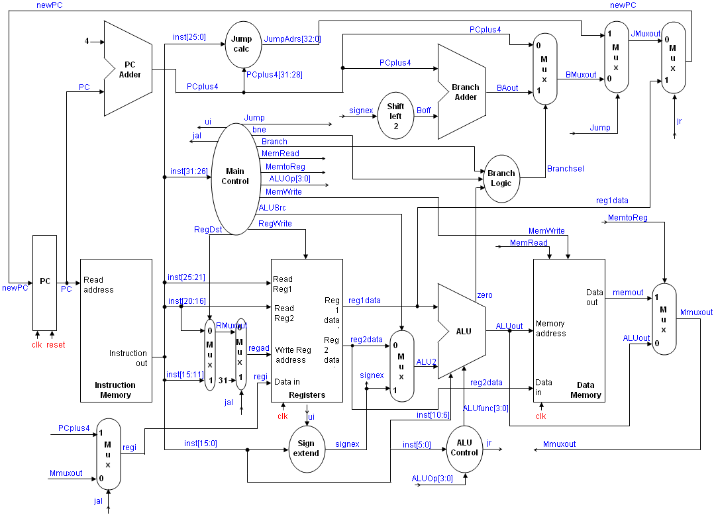
Figure 1. Control and datapath for the processor.
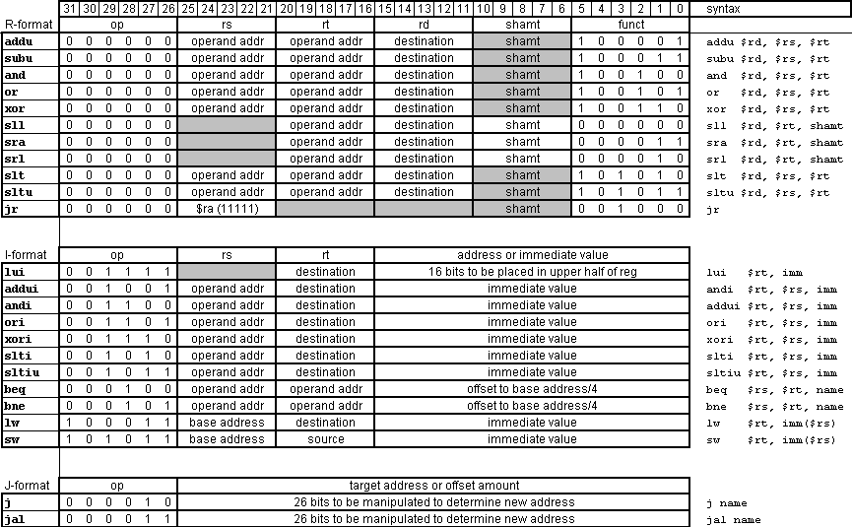

Table 1. Format for the requisite instructions.

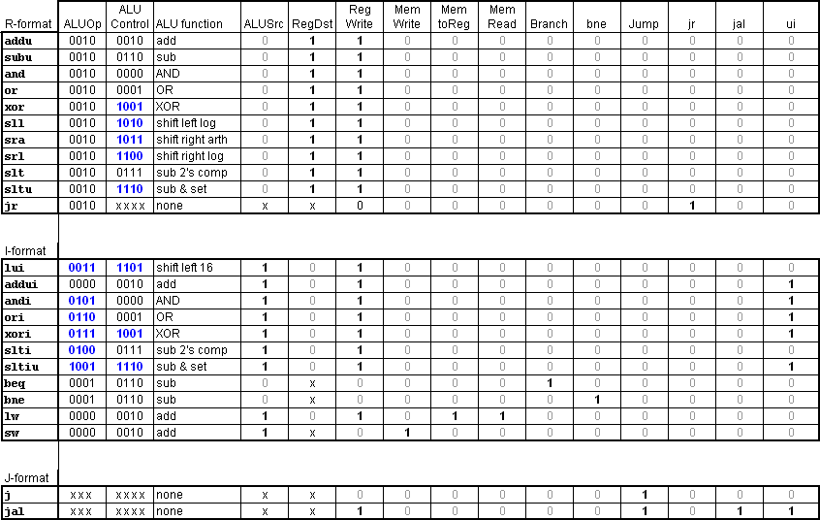

Table 2. Control signals for the requisite instruction set. My additions to the book’s ALUOp and ALU Control signals are
shown in blue.

Verilog Model:

I’ll begin coding modules moving from left to right and top to bottom across my flowchart. Some of them will be relatively trivial while others, like the ALU and the Main Control, will be fairly complex and will need to be tested independently.

PC Module
The PC is basically just a register, moving in the next instruction address on each clock cycle. It’s my only module with a reset, though, since it needs to be given a starting address for the first instruction of the program.

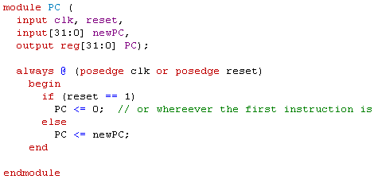

PC Adder Module
The PC Adder is also pretty simple. Rather than giving it an input of 4, I just “hardwired” it to always add 4 by putting it in the code. It is combinational logic and does not need a clock or a reset.

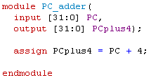

Instruction Memory Module
My Instruction Memory is not clocked. It’s simply combination logic that continuously outputs the instruction corresponding to the address it’s given by the PC module. I only gave my Instruction Memory 200 addresses, each being a byte. This will allow it to hold 50 instructions, which should be more than sufficient for my purposes.
I initialized the first 10 bytes for testing. When I actually run the processor I will have to initialize these with real instructions.

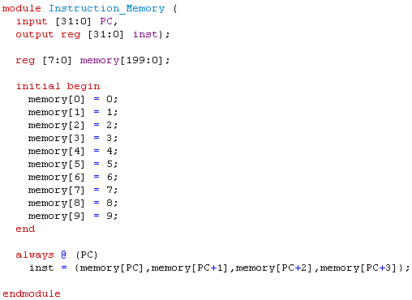

32-bit Mux Module
My 32-bit mux was straightforward. I used generic names for the inputs and outputs since I will reuse this module several times. I had to spell out “thirtytwo” in the module name.

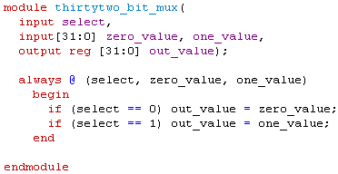

Jump Calc Module
This module was also straightforward, although I still think it’s a strange way to reference the jump-to address. This module simply concatenates the most significant 4 bits of PCplus4 with the 26 bits of immediate from the instruction with two zeros.

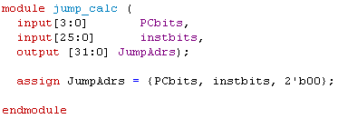

Main Control Module
My Main Control module is pretty long, but it’s not too complex. It simply performs a case on the most significant 6 bits of the instruction word and outputs its 12 control signals accordingly.

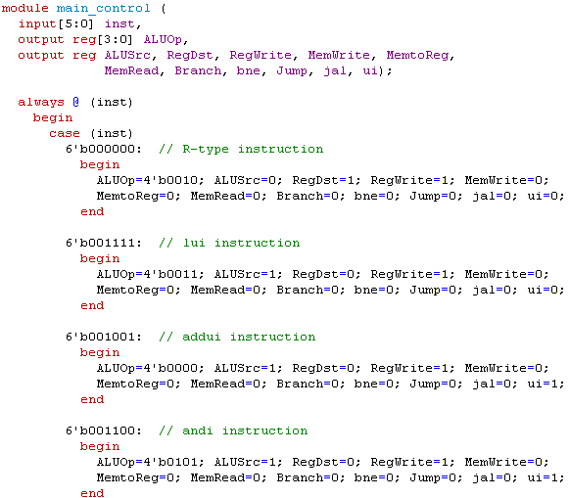
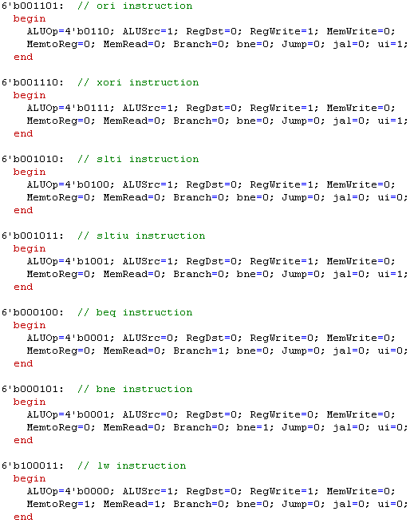
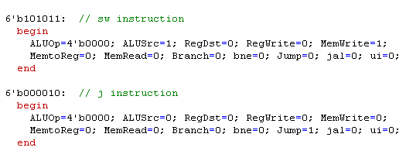
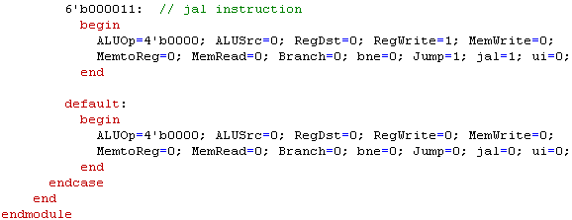

5-bit Mux
The 5-bit Mux module is identical to the 32-bit version, except with 5 bits.

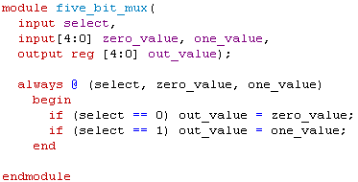

Registers Module
The Registers module must be clocked since they are registers. The inputs are the RegWrite signal, the register address to be written, regad, the data to be written, regin, and the two read addresses from the instruction. The outputs are the words read from the two read addresses, reg1data and reg2data.
The read portion of my register is combinational logic. It does not wait for the clock, but always outputs the data from the registers specified by the read addresses.
The write portion of my register is clocked. At the positive edge of the clock, if the RegWrite signal is asserted it will write the data waiting at its input to the write address. These signals and data are waiting there from the previous instruction.

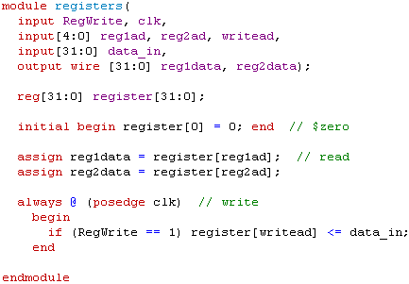

Sign Extend
The Sign Extend module is also straightforward, although during testing I found that I needed to add a ui signal for immediate values, which need to be unsign extended.

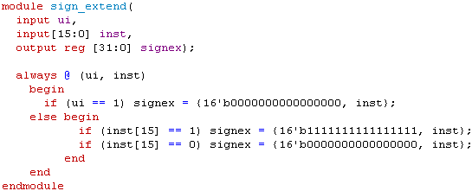

Shift Left 2
This module was also simple.

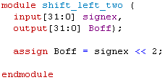
Branch Adder
Straightforward addition

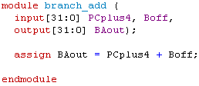

ALU Module:
This module is also kind of long, but not too complex. It has inputs of data, ALUfunc, and shamt. It simply has to look at the ALUfunc signal and decide what to do. I wrote the module all behaviorally.

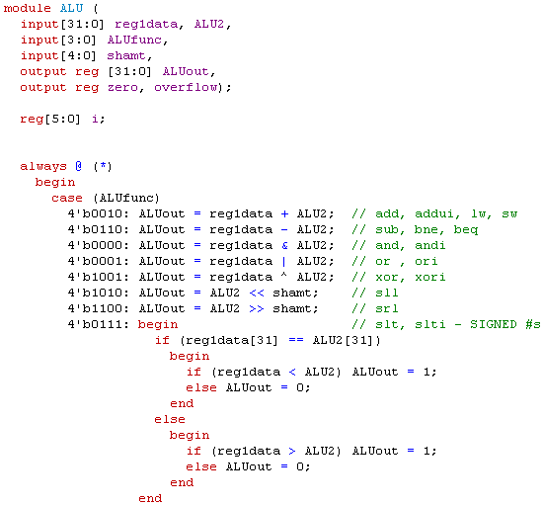

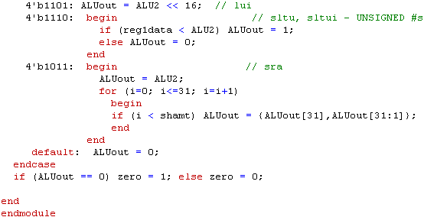

ALU Control
This module simply looks at the ALUOp signal and the function bits of the instruction and then determines what command to send to the ALU module.

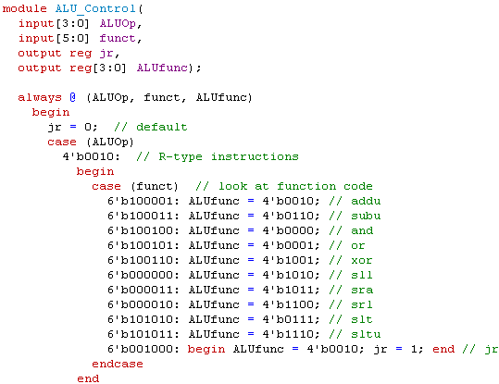

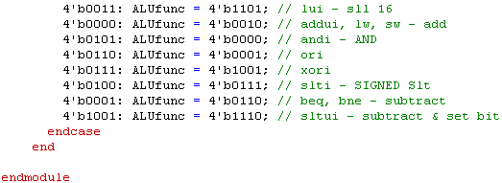

Branch Logic
This is a simple module to assert Branchsel when appropriate.

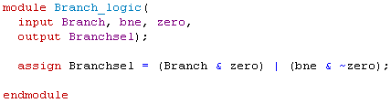

Data Memory
This module continuously reads with combinational logic but writes on the positive edge of the clock. A few of the values are initialized for testing.

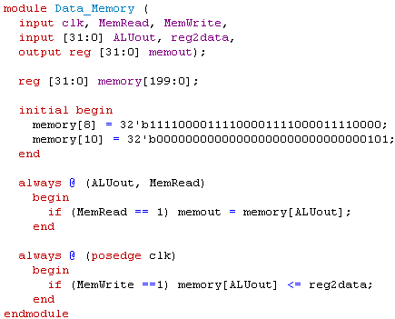
Main Processor
My Main Processor simply instantiates all of the other modules.

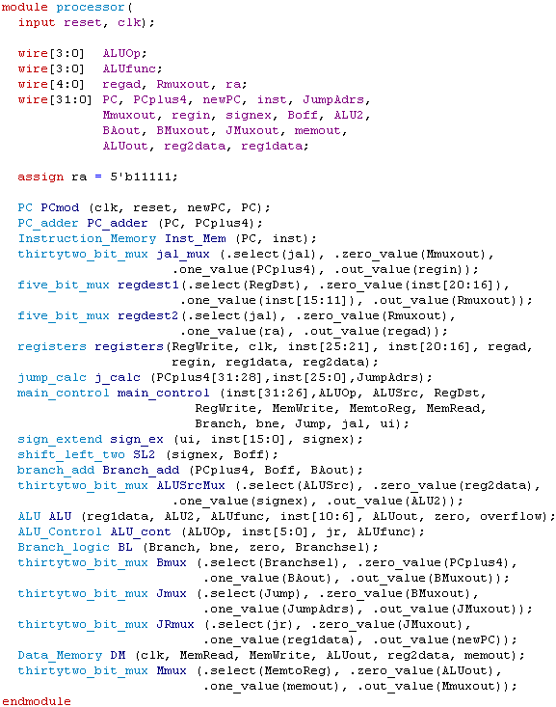

Test Bench
This is the test bench I used to simulate my processor. It’s very simple – it sends a reset, starts the clock running, and instantiates the processor module.

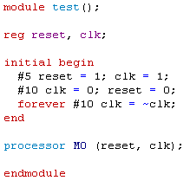

Testing:
I’ll test each of the instructions in the order shown in Table 1. I had to lengthen the off portion of my clock, making it non-symmetric, in order to see the current values of the signals of interest. I also had to run for a 2nd clock cycle in order to verify that the correct value was written to the correct register at the next clock cycle.
Most of my waveforms just show the instruction, the register inputs and outputs, and the specific register being written.

Add unsigned, addu:
I will simply tell it to add $r1 to $r2 and place the results in $r3, which will be a code of:

000000 00001 00010 00011 00000 100001

It worked! I set $r1 = 01010101….., and $r2 = 10101010….. The simulation is shown in Figure 2 below, which only shows the registers module. At the first positive edge of the clock reg1ad = 1, reg2ad = 2, RegWrite = 1, writead = 3, and the ALU must have performed the addition because regin = 11111111….. Further, on the next positive edge of the clock you can see that the result is written to register[3], as intended. (The 2nd instruction is meaningless, except for noting that the data was written to the register.)

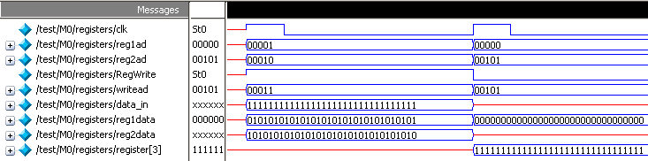
Figure 2. Registers module for the addu instruction.

Subtract unsigned, subu:
I will test this one similarly, simply changing the function code of the instruction. I’ll also change my register values to make checking the answer easy.
It worked again, as shown in Figure 3 below. The subtraction was performed and the result stored as $r3.

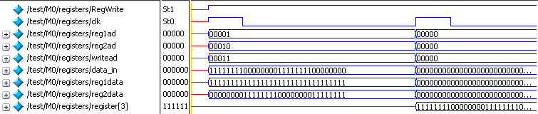
Figure 3. Simulation of the subu instruction.

AND, and:
I’ll use the same operands for the and operation. The result should be a little bit different, though. It worked again, producing a somewhat different result than the subu operation did.

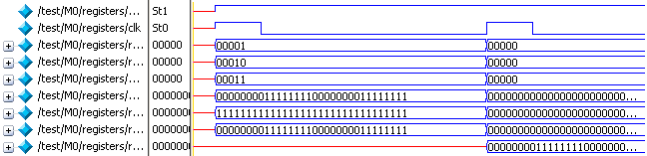
Figure 4. Simulation of the and instruction.

OR, or:
Using the same operands should give all 1s for the result, and it does.

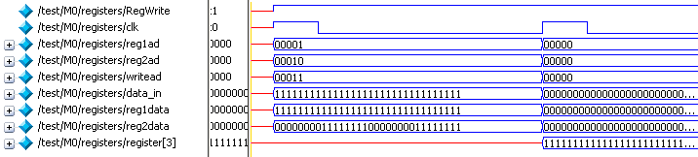
Figure 5. Simulation of the or instruction.

XOR, xor:
Again using the same operands, the result should the same as the subtraction. This instruction also works.

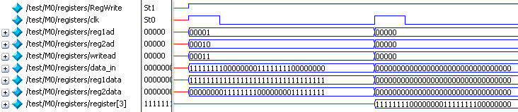
Figure 6. Simulation of the xor instruction.

Shift left logical, sll:
This one’s a little different. This time I’ll put a value of all 1’s into $r29, shift it left by 8, and store it into $r30. My instruction will look like this:

000000 xxxxx 11101 11110 01000 000000

This also worked, writing the correct value into $r30.

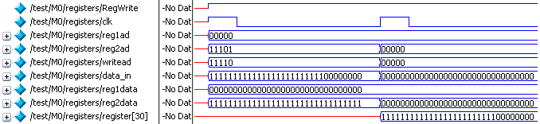
Figure 7. Simulation of the sll instruction.

Shift Right Arithmatic, sra:
I’ll first ask it to shift 32’b100000….. right by 8, which should end up with nine 1’s in the most significant bits. That worked, as shown below. I tried it with a leading 0, which also worked.

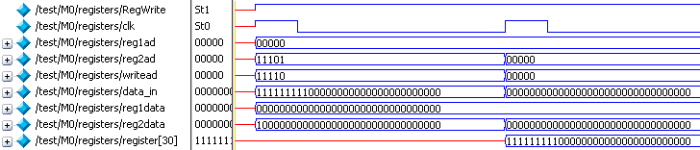
Figure 8. Simulation of the sra instruction.

Shift right logical, srl:
I’ll use the same operand and shamt from the sll instruction.

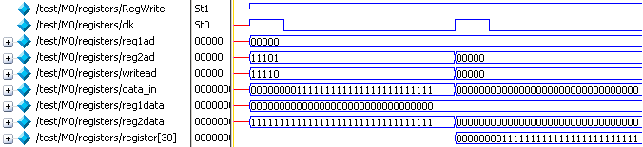
Figure 9. Simulation of the srl instruction.

Set less than, slt:
This instruction assumes signed values. I’ll test it a few ways: with two negative numbers, two positive numbers, and one positive and one negative number. It worked. The results are shown for -1₁₀ compared to 1₁₀.

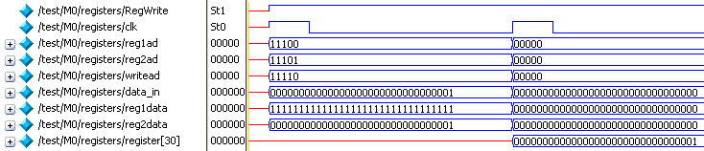
Figure 10. Simulation of the slt instruction.

Shift less than unsigned, sltu:
This instruction uses unsigned numbers. Again, I’ll test it a few ways. The test to compare all 1’s compared to 1₁₀ is shown below.

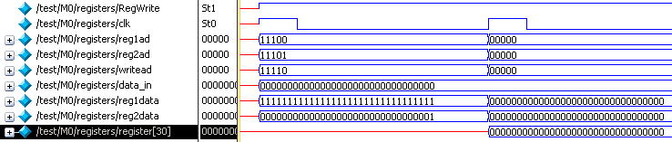
Figure 11. Simulation of the sltu instruction.

Jump return, jr:
For this instruction, I will put an easily identified number, 1111000011110000… into $r31, and this instruction should make that the new PC value, newPC. This, of course, won’t work with my Instruction Memory module, which only has the capacity for 200 bytes.
My first simulation attempt didn’t work because my Main Control module never asserted jr. I put the control of jr into the ALU Control module, and then it worked, as shown below.

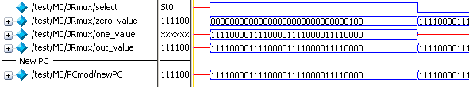

Figure 12. Simulation of the jr instruction.

Load upper immediate, lui:
For this I’ll load 16-bits into the upper half of register 20, using the instruction

001111 xxxxx 10100 1111001111001111

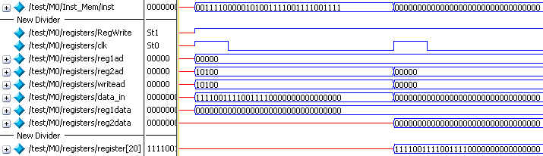

Figure 13. Simulation of the lui instruction.

Add immediate, addi:
Again using $r20 as the destination, I’ll add the same immediate value to its compliment, which I’ll put in register 21. The first time I attempted this it produced the wrong result. This was because I was sending all of my immediate values through the Sign Extend module, but I don’t want to sign extend my unsigned immediates. I fixed this with a new control signal that identifies unsigned immediates and has the Sign Extend module extend them with 0s. Then it worked.

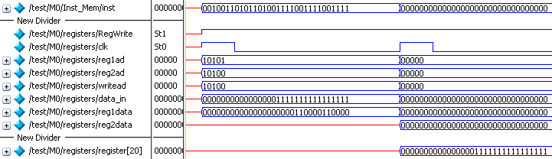

Figure 14. Simulation of the addui instruction.

AND immediate, andi:
I again used values that would be easy to read.

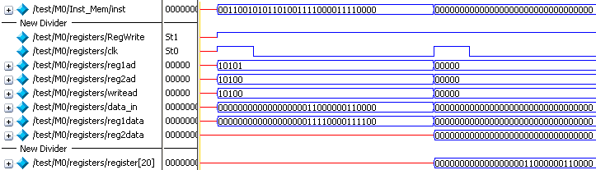

Figure 15. Simulation of andi instruction.

OR immediate, ori
Using the same values, just changing the op code, gives

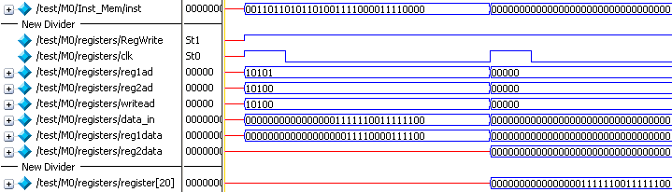

Figure 16. Simulation of ori instruction.

XOR immediate, xori:
Using the same values:

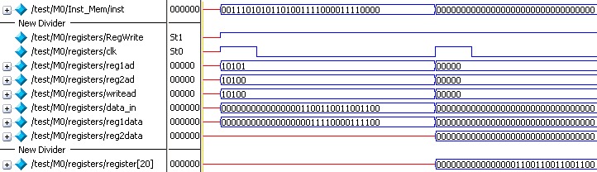

Figure 17. Simulation of the xori instruction.

Set less than immediate, slt:
This instruction assumes signed numbers. I’ll make $rs all 1’s, which should be less than my immediate value of 1₁₀. It works:

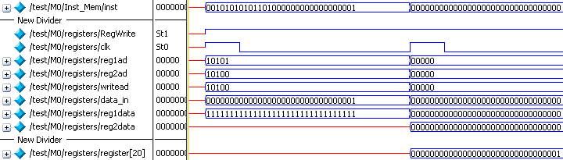
Figure 18. Simulation of slti instruction.

Set less than immediate unsigned, sltiu
Using the same values, this instruction should return 0, and it does.

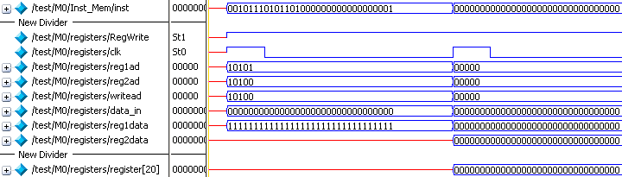
Figure 19. Simulation of sltiu instruction.

Branch if equal, beq:
Finally, something a little more interesting. For this instruction I need to specify two register addresses and an offset to the PCplus4 address. I’ll use registers 10 and 11, setting them equal so it should jump. For the offset, I’ll use 1110₂, which should be shifted to 111000, then added to 100, to give 111100 for the newPC signal. That worked, as shown below. I also tested it with the registers not equal, to make sure it wouldn’t branch, and it didn’t.

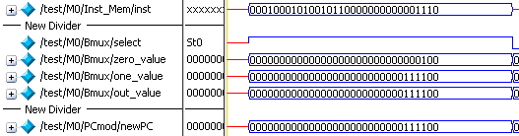
Figure 20. Simulation of beq instruction.

Branch not equal, bne:
I’ll use the exact same values as before and test both equal and not equal. It worked. The branch is shown below.

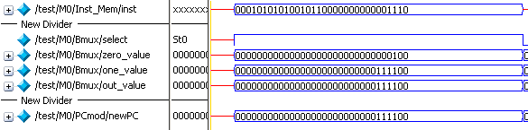
Figure 21. bne instruction.

Load Word, lw:
For this I’ll put a word in the memory and see if I can get it out. I’ll put it into register 16. I’ll make the base address of my memory 4₁₀, and the offset also 4₁₀, so it should get the value that I’ve hidden in memory[8] of my Data Memory module. It worked.

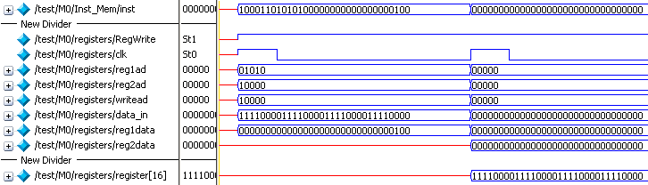

Figure 22. Simulation of lw instruction.

Store word, sw:
I’ll store an easily recognizable word from register 10 into memory[10]. I’ll do that by making the base address of my memory 0 and adding 10 to it. It worked after I fixed my Main Control module to assert MemWrite.

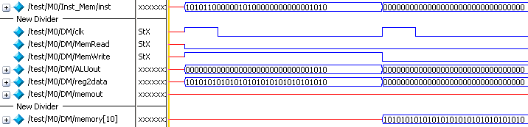

Figure 23. Simulation of sw instruction.

Jump, j:
To test this instruction, I will set my 26-bit jump value to 11₂ (3₁₀) This will then be shifted left by 2 to become 1100₂ (12₁₀) and then concatenated with the leftmost 4 bits of PCplus4 to become newPC. I’ll put all 1s into the instruction starting at 12, and this should show up as the next instruction.

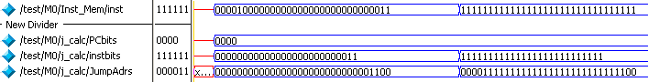

Figure 24. Simulation of j instruction.

Jump and Link, jal:
I’ll use the same new address as before. This time, though, my processor should store the original PCplus4, 0100₂, into register 31.

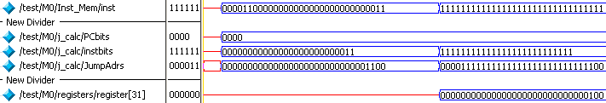

Figure 25. Simulation of jal instruction.

Advanced Simulation:

Testing of the individual instructions was tedious. For something more interesting, I am going to write a short program using each of the instructions one time. Below is my program in assembly language. It has no specific purpose, but uses each of the instructions in somewhat random order, with most instructions using the values from the previous instructions and writing to the next incremental register.

1. lui $1, 1111111111111111 # Put all 1’s into the upper half of $1
2. sra $2, $1, 16 # This should fill $2 with 1’s
3. sll $3, $2, 16 # This should make $3 16 1’s and 16 0’s
4. srl $4, $3, 24 # This should set $4 to 11111111₂
5. addui $5, $0, 17 # $5 = 0 + 1111 = 1111
6. subu $6, $4, $5 # $6 = 11111111 – 1111 = 11110000
7. addu $7, $6, $4 # $7 = 11110000 + 11111111 = 111101111
8. and $8, $7, $6 # $8 = 111101111 & 11110000 = 11100000
9. xor $9, $7, $6 # $9 = 111101111 ^ 11110000 = 1000111111
10. slt $10, $1, $9 # $1<0, $9>0, so $10 = 1
11. bne $10, $0, xxx # should branch. I’ll add 8 for branch
12. or $11, $7, $9 # $11 = 111101111 | 1000111111 = 111111111
13. jal xxxx # I’ll add 16 to the current PC+4
14. andi $12, $11, 1010 # $12 = 111111111 & 1010 = 1010
15. jr $31 # PC should return to old PC+4
16. j zzzz # I’ll jump past the jal instructions
17. lw $13, 0($12) # load memory[10] (0101) into $13
18. xori $14, $13, 1110 # $14 = 0101 ^ 1110 = 1011
19. ori $15, $13, 1110 # $15 = 0101 | 1110 = 1111
20. sltu $16, $1, $9 # $1>>0, $9>0, so $16 = 0
21. slti $17, $1, 0 # $1<0, so $17 = 1
22. sltiu $18, $1, 0 # $1 >> 0, so $17 = 0
23. beq $16, $18, yyyy # $16 = $18 so it should branch
24. sw $11, 4($12) # store 111111111 into memory[14]

Coding this into machine language, I get

op rs rt imm
1. lui $1, 1111111111111111 001111 xxxxx 00001 1111111111111111

op rs rt rd shamt funct
2. sra $2, $1, 16 000000 xxxxx 00001 00010 10000 000011
3. sll $3, $2, 16 000000 xxxxx 00010 00011 10000 000000
4. srl $4, $3, 24 000000 xxxxx 00011 00100 11000 000010

op rs rt imm
5. addui $5, $0, 17 001001 00000 00101 0000000000001111

op rs rt rd shamt funct
6. subu $6, $4, $5 000000 00100 00101 00110 xxxxx 100011
7. addu $7, $6, $4 000000 00110 00100 00111 xxxxx 100001
8. and $8, $7, $6 000000 00111 00110 01000 xxxxx 100100
9. xor $9, $7, $6 000000 00111 00110 01001 xxxxx 100110
10. slt $10, $1, $9 000000 00001 01001 01010 xxxxx 101010

op rs rt imm
11. bne $10, $0, xxx 000101 01010 00000 0000000000000010

op rs rt rd shamt funct
12. or $11, $7, $9 000000 00111 01001 01011 xxxxx 100101

op jump bits
13. jal xxxx 000011 00000000000000000000000010

op rs rt imm
14. andi $12, $11, 1010 001100 01011 01100 0000000000010010

op rs rt rd shamt funct
15. jr $31 000000 11111 xxxxx xxxxx xxxxx 001000

op jump bits
16. j zzzz 000010 00000000000000000000010100

op rs rt imm
17. lw $13, 0($12) 100011 01100 01101 0000000000000000
18. xori $14, $13, 1110 001110 01101 01110 0000000000001110
19. ori $15, $13, 1110 001101 01101 01111 0000000000001110

op rs rt rd shamt funct
20. sltu $16, $1, $9 000000 00001 01001 10000 xxxxx 101011

op rs rt imm
21. slti $17, $1, 0 001010 00001 10001 0000000000000000
22. sltiu $18, $1, 0 001011 00001 10010 0000000000000000
23. beq $16, $18, yyyy 000100 10000 10010 0000000000000010

op rs rt imm
24. sw $11, 4($12) 101011 01100 01011 0000000000000100

Before running this I changed my instruction memory program to hold 32-bit words so that I would not have to break each of these machine code instructions into four 8-bit bytes. I did not change the PC logic, though, so I’m storing my 32-bit words in every 4th memory space.
Running this, naturally, did not go nearly as smoothly as planned. I found several bugs caused by errors in my machine language coding. But I also found that my beq and bne instructions did not work because of a change I made to my ALUOp codes to make my sltiu instruction work. When I changed the ALUOp for sltiu, I also changed it for beq and bne, causing them not to work.
I tried to find a way to remedy this situation without adding a bit to my ALUOp signal, but I couldn’t. The problem is that I have eight different ALU functions to be performed for the non-R-type instructions, but only seven 3-bit ALUOp codes available. So I fixed it by adding another bit to ALUOp.
The code for my Instruction Memory for executing this program is shown on the next page.
The results of the working simulation are shown on the last page. It worked well after I fixed the typos, corrected my instructions for the jump instructions, and fixed the ALUOp signal so that the sltiu command would work.
I have displayed the newPC, the current instruction (which is unreadable but I used it for debug), and the registers that are written to, along with the control signals from the Main Control module. You can see on the waveforms that the newPC signal follows my intended instruction path, and that the registers are each updated with the correct values as the program proceeds. Finally, the correct value is written into memory[14] in the Data Memory module.

Instruction Memory module modified for the program:

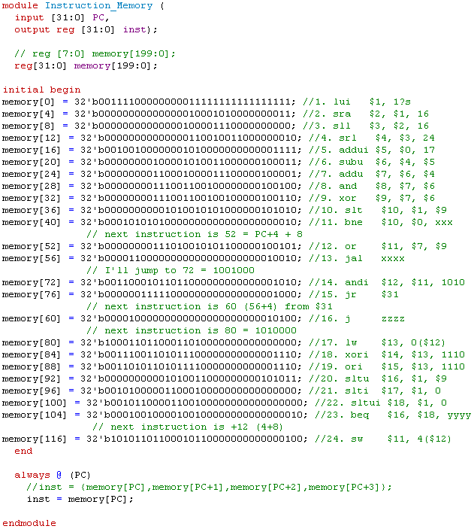

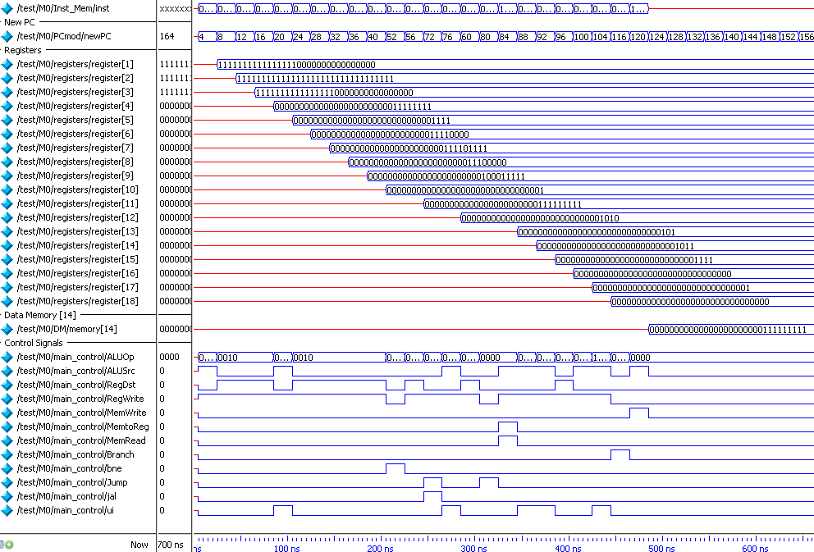

Figure 26. Simulation of the program using all 24 instructions.

